

COMPANY HANDBOOK

ANSWERS TO MOST
OF YOUR QUESTIONS








VERSION 11
August 3, 2016
The Ben Franklin Technology Partners is an initiative of the Pennsylvania Department of Community and Economic Development and is funded by the Ben Franklin Technology Development Authority
Table of Contents
INTRODUCTION 3
DISCLAIMER 4
PAYMENTS BY BEN FRANKLIN TECHNOLOGY CENTER 5
How will my funds be distributed? 5
When can I expect the first check? 5
When can I expect the next check? 5
What happens if I have not expended 80% of the first increment? 5
When can I expect the third installment? 5
What happens in April? 6
What happens if my award starts on or about October 1? 6
What happens if my award starts on or about January 1? 6
What happens if my award starts on or about April 1? 6
What happens if my end date is prior to June 30? 6
What happens if I finish my project prior to my contract end date? 7
What happens if I don’t expend the entire amount allocated to me? 7
What happens if I need more funding? 7
I have a question not addressed here 7
REQUIRED COMPANY REPORTS 8
When are reports due? 8
Will I get a reminder notice? 8
Why do I need to send copies of invoices and other back-up for all expenses? 8
What is considered allowable? 9
Can I make changes in the budget after the funding starts? 9
Give me some examples of charges that are not allowable. 9
What about equipment purchases? 9
REMINDER FOR CREDIT CARD AND DEBIT CARD PURCHASES 10
TIPS FOR FINANCIAL REPORTING 11
REQUIREMENT FOR FINANCIALS 13
SERVICES OF THE BEN FRANKLIN TRANSFORMATION BUSINESS SERVICES NETWORK 14 - 16
SAMPLE IMPACT SURVEY 17



INTRODUCTION

Welcome to Ben Franklin Technology Partners of Central and Northern Pennsylvania (BFTP/CNP)! All of us at the Center are excited about working with you in the coming months as your project progresses. We are available to assist you and answer any questions you may have.
This handbook is designed to answer the questions most frequently asked by entrepreneurs new to our program. It will help you anticipate report requirements, introduce you to the Transformation Business Services Network, and spell out some of the guidelines by which we operate.
If there is a topic or issue that you feel needs to be addressed in this handbook, please let me know. I’ll put it in the file to be included in the next edition.
If you need to talk with me about anything, I’m always just a phone call or e-mail away. Don’t ever hesitate to call or write.
I look forward to working with you, and wish you the very best with your project.
Kathleen D. Matason
Director of Operations

Ben Franklin Technology Partners,
Central & Northern PA
200 Innovation Boulevard, Suite 150
State College, PA 16803

kdmatason@cnp.benfranklin.org

814-863-4884 voice
814-865-0960 fax



DISCLAIMER

The funds distribution described here is representative of the method that would be used under an award in which there are no contingencies.
In the event of contingencies, the percentages paid out in each distribution, with the exception of the first, may differ.
Under most circumstances, the third payment (typically in January) will bring the amount distributed to that date to 90% of the award amount.
Ten percent is always retained and paid after the final report is received and approved.

PAYMENTS BY BEN FRANKLIN TECHNOLOGY CENTER

How will my funds be distributed?
Your Ben Franklin funding will be paid in installments and subject to certain conditions. Ten percent (10%) of the awarded amount will be withheld to the end of the contract period and paid after submission of a comprehensive final report. Your portfolio manager will ascertain completion of the project and will approve the final report prior to the release of the final increment of funding.

When can I expect the first check?
At the Kick-off Conference, if you bring all copies of your signed contract. Otherwise, when a copy of the fully executed contract is mailed to you, a check for one-third of 90% of your awarded amount will be included.

When can I expect the next check?
Your contract includes a schedule for quarterly reports. Quarterly reports are due in October, January, and April. An e-mail notice will go out to Companies when the electronic format for the current quarter is available on our website. The October report covers the first quarter; the January report covers the second quarter; and the April report covers the third quarter. When you submit your first quarterly report in October, Ben Franklin’s Director of Operations will review it for compliance to our guidelines. If everything is in order, and 80% of the first increment has been spent, the second installment (1/3 of 90% of the awarded amount) will be released.

What happens if I have not expended 80% of the first increment?
You may submit a revised quarterly report (paper format) at the point at which you reach expenditures of 80% of your first increment. You need not resubmit documentation already included in the first quarterly report. Simply complete the summary sheet (available upon request to the Director of Operations) to include expenses from the start of the contract to the appropriate date, and include back-up only for those expenses that occurred after the date of your initial quarterly report. Upon approval of the Director of Operations, the second increment will be released.

When can I expect the third installment?
In similar fashion to the second increment, the third will be released upon completion of the mid-year report, which is due in January. You need to have expended 80% of the first two increments combined. In addition, you need to be on track with your matching funds. Should you not be at the 80% expenditure point, follow the same procedure outlined in the paragraph above.

What happens in April?
You are expected to provide a quarterly report in April. Under the typical twelve-month award beginning July 1 and ending June 30, there will be no funding increment associated with this report. However, this report provides the opportunity for us to assess the likelihood of you meeting remaining milestones, finishing the project, and expending allocated funds. Should you need assistance in any of these areas, or others, we have sufficient time to intercede and ensure a positive outcome to your project.

What happens if my award starts on or about October 1?
A payment will be associated with April. You would have received 1/3 of 90% of your awarded amount with your contract. In January, your first report would have been due, and the second increment paid (subject to the same conditions outlined above). Thus, in April you would be submitting your second quarterly report, and would receive the third increment of 1/3 of your awarded amount.

What happens if my award starts on or about January 1?
Ten percent (10%) of your awarded amount will be withheld and paid at the end of the project, subject to the conditions outlined above. A check for one-half of 90% of your awarded amount will be included with your fully executed contract. In April, after your first quarterly report is approved, you will receive the second increment of one-half of 90% of your awarded amount, subject to the 80% expenditure rule.

What happens if my award starts on or about April 1?
You will receive 90% of your awarded amount with your fully executed contract. The final 10% will be released after you complete a final report, subject to approval by your portfolio manager and Director of Operations.

What happens if my end date is prior to June 30?
Occasionally, an award is made for a six-month period from July 1 through December 31. In this case, you would receive one-half of 90% of your awarded amount with the copy of the fully executed contract and one-half of 90% of your awarded amount in October, subject to submitting an interim report and expending 80% of the first increment. The final payment would occur in January, after you had submitted a comprehensive final report that was approved by your portfolio manager and the Director of Operations.

What happens if I finish my project prior to my contract end date?
After consultation with, and approval by, your portfolio manager, you may submit a comprehensive final report. You may request the guidelines from our Director of Operations. When the report and financial information are approved, your final check will be issued.

What happens if I don’t expend the entire amount allocated to me?
You are not required to spend all of the funds. If you find that you have been able to complete the project at a lesser cost, that amount will be subject to payback conditions. You will not be responsible for payback associated with the contract amount, but the amount actually expended on the project.

What happens if I need more funding?
You should discuss your situation with your portfolio manager. If he or she decides that additional funding would enhance the progress of your project, you may be able to propose an addendum to your contract, subject to approval by the Ben Franklin/CNP Board of Directors. This is contingent upon there being funds available for distribution in the current fiscal year.

I have a question not addressed here
Contact Kathleen D. Matason, Director of Operations, 814-863-4884,
kdmatason@cnp.benfranklin.org

REQUIRED COMPANY REPORTS

You are required by our guidelines and your contract to submit quarterly reports and a comprehensive final report. Reports typically are linked to the release of your incremental payments of the funding you have been awarded (see Payments by Ben Franklin).

When are reports due?
Reports are due at the end of October, January, April, and July.

Will I get a reminder notice?
About two weeks prior to the end of the quarter, you will receive an e-mail alerting you to the availability of the web-site reporting format for the quarter. You are required to send copies of invoices and other back-up for Ben Franklin expenses only. Matching expenses must be identified as cash or in-kind (there is pull-down menu). You will be asked to prepare a short narrative of progress to date and include copies of any publicity or promotional items that were published in the last quarter.

Why do I need to send copies of invoices and other back-up for all expenses?
Ben Franklin Technology Centers act as stewards of public funds and, as such, are accountable by both legislation and guidelines to ensure proper use of those funds. Ben Franklin/CNP utilizes the accounting systems of The Pennsylvania State University and adheres to all policies and procedures that have been put in place to ensure proper expenditure of state, federal, and industrial funds. Appropriate back-up materials are required by both the Penn State auditors and the independent auditors that Ben Franklin Centers are required by guidelines to hire.
In light of these requirements, it is prudent for our Director of Operations to verify and approve expenditures against Ben Franklin funds and matching expenses, too. This ensures that our files will be complete and that you will not be surprised by disallowable expenses in Ben Franklin funds or matching funds after your award has expired. Should claimed Ben Franklin expenditures be judged disallowable at that point, you would have to pay back the disallowed amounts immediately. If matching costs are disallowed and your match falls below the amount of Ben Franklin funding, your award amount could be decreased. If our Director of Operations tracks your expenditures on a quarterly basis, you can be sure that your expenses and match are allowable.

What is considered allowable?
Your best guideline to allowable costs is your fully-executed contract. A copy of your approved budget is included in your fully-executed contract. Be sure to use this budget, not the budget in your proposal, because changes could have occurred during the approval process. Generally speaking, anything that relates directly to the project is allowable.

Can I make changes in the budget after the funding starts?
The budget you begin with is designed to be a guide for you and a means by which your portfolio manager and our staff can assess the likelihood of you achieving success in your project. As such, it can be considered a living document, subject to changes and tweaks as the project progresses. However, you must discuss changes in your budget with your portfolio manager or the Director of Operations. Not only does this ensure that the change is appropriate and that it enhances the progress of the project, it allows the change to be documented in your file so that there is justification for the change when it appears on your quarterly or final report.

Give me some examples of charges that are not allowable.
Overhead Janitorial Services Utilities Alcoholic Beverages Cleaning Supplies Rent High-Cost Travel Coffee Supplies Movies Furniture Equipment Patent Costs Over $10K
Credit card receipts and/or statements that do not include details of the purchase. You may not submit the credit card receipt with only a signature. Be sure to obtain and include the details of what was purchased. For example, when you purchase a meal by credit card, you receive from the merchant the details of what was ordered in addition to the customer copy of the credit card purchase record. We can allow only the detailed receipt. This applies to purchases made in stores and on line.

What about equipment purchases?
Equipment is not an allowable Ben Franklin expense.
Equipment is allowable as match at the same rate that your accountant uses for IRS depreciation.



REMINDER FOR CREDIT CARD AND DEBIT CARD PURCHASES

I must have an itemized receipt, not just the signed yellow or white receipt copy for credit card purchases.
If you dine in a restaurant, you will receive an itemized bill for payment. Be sure to keep this itemized bill when you sign the credit card receipt.
If you order an item on-line, be sure that the e-mailed verification of your order includes the date ordered. I must have a copy of the verification listing items ordered and date ordered.
A bank statement is not sufficient documentation. If you use a debit card, get the itemized receipt.
I must disallow any receipt that is not itemized and dated.
Questions?
Call me at 814-863-4884 or e-mail me at kdmatason@cnp.benfranklin.org.
Kathy Matason



TIPS FOR FINANCIAL REPORTING

ALLOWABLE COSTS
- Those items specified in your budget.
- Budget change items discussed with and approved by your portfolio manager.
- Only costs directly related to the project.

NON-ALLOWABLE COSTS
- Rent and utilities.
- Equipment.
- Expenses not directly related to the project, i.e., cleaning supplies, toilet paper, trash bags, coffee supplies, etc.

HANDLING EQUIPMENT COSTS
If equipment is part of your match, you may use only the amount that is calculated by your accountant for IRS depreciation. Equipment is not an allowable purchase with Ben Franklin funds.
COPIES OF INVOICES
Please include copies of all invoices or other proofs of cost. This applies to the Ben Franklin expenses only. An easy way to do this is to put a copy of the invoice in a special file folder marked “Ben Franklin Reports” when the invoice is paid. You will have all invoices in one place, ready to send, when you complete your interim and final reports.
CREDIT CARD PURCHASES
Credit card receipts with signature only are NOT ALLOWABLE. You must submit an itemized receipt, one of which is included with all credit card purchases.
QUESTIONS??
Call or e-mail Kathy Matason, 814-863-4884, kdmatason@cnp.benfranklin.org.


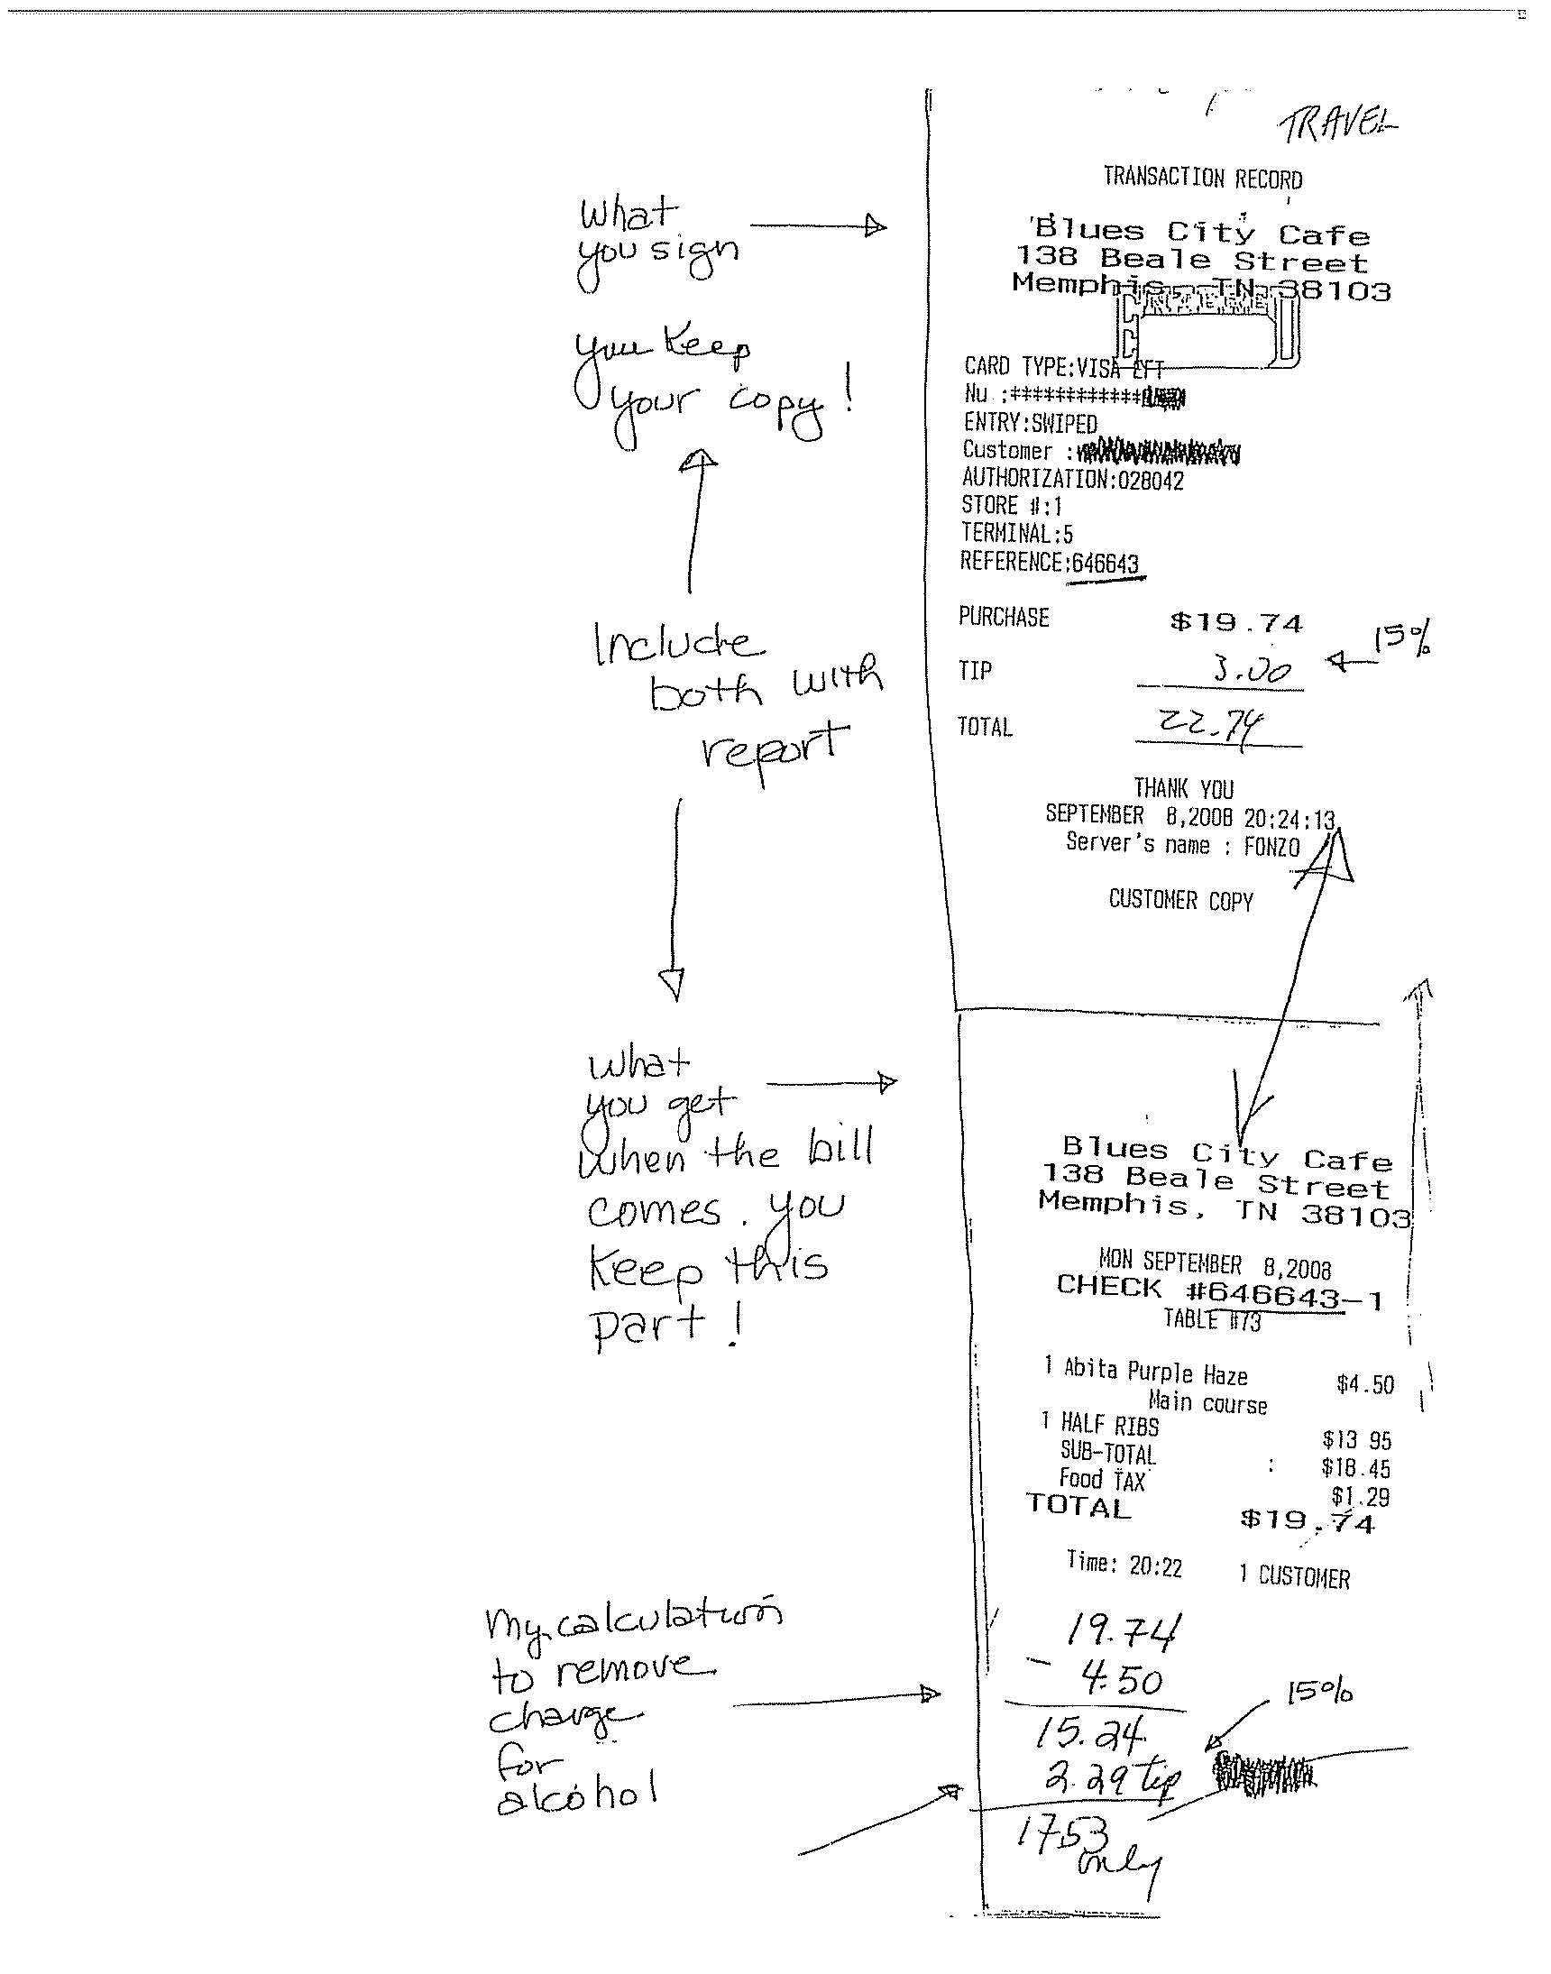

REQUIREMENT FOR FINANCIALS

Your contract requires the submission of quarterly, in-house financials 30 days after the close of each quarter. Typically, these are included with the back-up documentation for the quarterly report. The financials must consist of both a Balance Sheet and an Income Statement, at a minimum.
Your contract requires that you submit accountant-prepared financials within 90 days of the close of your fiscal year.
E-mail reminders will be generated, when necessary.
Failure to submit financials is a condition of default of your contract.
Should you have difficulty providing these documents, please notify your portfolio manager so that alternative arrangements can be approved and documented.


SERVICES OF THE BEN FRANKLIN TRANSFORMATION BUSINESS SERVICES NETWORK
Ben Franklin/CNP funds the Ben Franklin Transformation Business Services Network (TBSN) to directly support the activities of start-up companies. Personnel in the TBSN are available to work on specific problems of emerging companies.
TBSN provides tools to train business owners and their employees in a number of human resource and financial management areas. Each tool from the TBSN is a specific intervention and reflects approximately ten hours of engagement by the TBSN staff.
Human Resource Tools
Competitive advantage may be achieved by firms that appropriately manage their employees. The issues addressed in these tools will assist the efficient and effective management of this resource to achieve strategic organizational objectives.
Employee Relations
This activity will assist the organization in identifying personnel needs and providing the ongoing support to establish and maintain a stable and productive workforce.
Office Organization
The answers to better office management lie in the analysis of existing procedures and the introduction of improved processes or equipment to address current and future needs. This activity provides insights for improving office performance.
Employment Interviews
Recruitment and selection are at the heart of many organizational and management challenges. Understanding the available options and methods will help to find the right person for the job.
Manage and Motivate Employees
A leader must have someone to lead. Satisfied employees will result in a stable environment from which to grow a business.
Computer Training
Information technology and computer systems represent valuable tools in the successful management of a business. Proper training in the use of these systems will benefit the company in utilizing these resources to the best advantage.

Strategies for Organizational Change
A growing business and increasing volume generate additional duties and responsibilities. Managing the changes provides for an improved allocation of energy and delegation of work to better benefit the business.
Employee Record Keeping
As the business grows and the number of employees increases, the need for a formal tracking system becomes apparent. This tool helps to address employee records issues to satisfy legal, ethical and good business issues.
Supervisory Responsibilities
Clear personnel policies and expectations should be established as early as possible. These become useful guides in all areas including recruitment and selection, compensation and benefits, training and promotions.
Effective Skills Training
Peak performance in the work place begins with effective on-the-job training (OJT). This activity offers practical tools that help participants develop and deliver effective OJT.

Supervisory Skills for Administrative Assistants and Secretaries

This activity provides supervisors in administrative positions with the skills necessary to
manage their work and supervise staff. It helps to develop practical guidelines for managing communication and fostering staff development.

Financial Tools

Businesses owners need to communicate their results. These tools will enable a business owner to provide necessary financial information to the outside world, including investors and tax authorities. Within the company, the training provides the means to control, evaluate and plan the business.

Install Computerized Accounting System

This activity provides valuable assistance in the selection, installation and basic operation of a computerized system for recording the financial transactions of a business. New and rapidly growing businesses encounter increasing and changing demands for financial record keeping and reporting. This tool provides assistance in upgrading or converting to a new system that will satisfy expanded and anticipated future requirements.

Train on Client’s Accounting Software
TBSN can provide specific accounting system support to provide a company’s employees the needed skills for recording and reporting financial information consistent with the need of the business.
Implement Payroll on Computerized Accounting System
Timely and accurate payroll information is critical not only to satisfy financial record keeping and tax reporting requirements, but also to complement the personnel function.
Cost Accounting
This tool provides the necessary direction to properly assign costs for financial reporting, operations planning and marketing decision making.
Establish Inventory System
Timely and accurate records for raw materials, work-in-process and finished goods are necessary for meeting customer deliveries while managing cash flow. This tool provides the foundation for controlling one of the most cash-consuming items appearing on many balance sheets.
Develop Pro-Forma Statements
This tool provides the basis for demonstrating the past, current and projected financial performance of the business. The three basic financial statements created represent standard input to business plans and are highly scrutinized by potential lenders and investors.
Create What-If Scenarios
After pro-forma financial statements have been developed, alternative business strategies can be analyzed. These strategies include sales volumes, pricing, labor costs, capital expenditure plans and others. The use of this tool demonstrates the financial outcomes of various client plans and assumptions.
Budget Preparation
Based upon the company’s projected plans for revenues and expenditures, the budgeting tool develops the resulting financial statements for that fixed period. The budget becomes the baseline against which to compare actual performance, take corrective actions when necessary, and develop longer-term strategies.

Management Information Packages
Monthly financial reports provide management with the opportunity to monitor performance, identify problem areas and make adjustments in a timely fashion.
Year-end Processing
This tool provides assistance in closing the books for the year and developing the necessary information for tax return preparation.
IMPACT REPORT

Benefits of the BFTP program to the Commonwealth of Pennsylvania are reported once a year. Requests for completion of your electronic impact form will be emailed to the person who signed your contract starting in October. In order to meet the Commonwealth deadline for reporting, we strongly encourage you to complete the report prior to the end of the calendar year. Ben Franklin staff will be available to assist you.
The specific quantitative performance measures reported via the impact report by companies served by the Center are:
- Number of new companies formed.

- Dollars of revenue earned.

- Number of jobs created.

- Number of jobs created with an annual salary that meets or exceeds an amount specified in the electronic form.

- Number of jobs retained.

- Number and description of new products commercialized.

- Number and description of new internal processes implemented.

- Dollars of research, development, testing and evaluation expenditures.

- Number of patents and software copyrights.

- Number of licenses granted to other PA companies.

- Dollars of licensing revenue earned.

- Dollars of additional funding obtained.

